**ECE 491 Mechatronic Systems Design**

**Project Proposal**

**Team members: Abhra Sinha, Pratik Walawalkar, Eshan Gupta.**

1. **Team Name**

Scavengers

1. **Overall Strategy**

A model car without control is useless even though if runs at maximum speed. So, while building our autonomous model car we plan to focus more on the **expert navigation** and the robustness. It should follow the closed loop path accurately even if it moves slow. We plan to minimize this time later once overall structure is finalized. We plan to make a reliable vehicle by testing the control algorithm to enable the smooth and robust operation of the steering action and the line detection.

If time permits we plan to attach a Bluetooth module for effective transmission of sensor readings for monitoring and debug in case of malfunctioning or for calibration.

The following strategy will be followed in building our vehicle for the final race track:

1. Accurate data acquisition by line camera and data processing by the microcontroller
2. Precise control algorithm to focus on expert navigation to maintain a balance of speed and steer.
3. Algorithm would give higher priority to sensor for accurate sensing mechanism and accordingly decide the actuator values
4. Precise steering using the servo motors and fine tuning of the duty cycle of the pulse given to the servo motor and to the dc motor for precise speed control
5. Better power distribution technique by implementing efficient motor drivers and voltage regulators and optimized placement of the components.

List of anticipated sensors:

1. Line camera: Track detection and data acquisition
2. Accelerometer/Optical encoder: Speed measurement
3. IR sensor: Used as a failsafe condition for line detection (In case of missed detection by the line camera)
4. Ultrasonic sensors (Additional component if time permits): Obstacle detection

NXP Cup – No, since we are 3 graduate students and cannot participate in the competition.

1. **Hardware Design**
   1. Attachments to vehicle
2. Line scan camera - 2
3. Servo motor
4. Optical Encoder/Accelerometer/Hall effect sensor
5. Microcontroller Board
6. Ultra-Sonic sensor
7. Motor Driver Board
8. Power Delivery Board (Voltage Regulator)
9. DC motor
10. Battery pack
11. Bluetooth module
12. LCD Display
13. LED Grid for Illumination
    1. 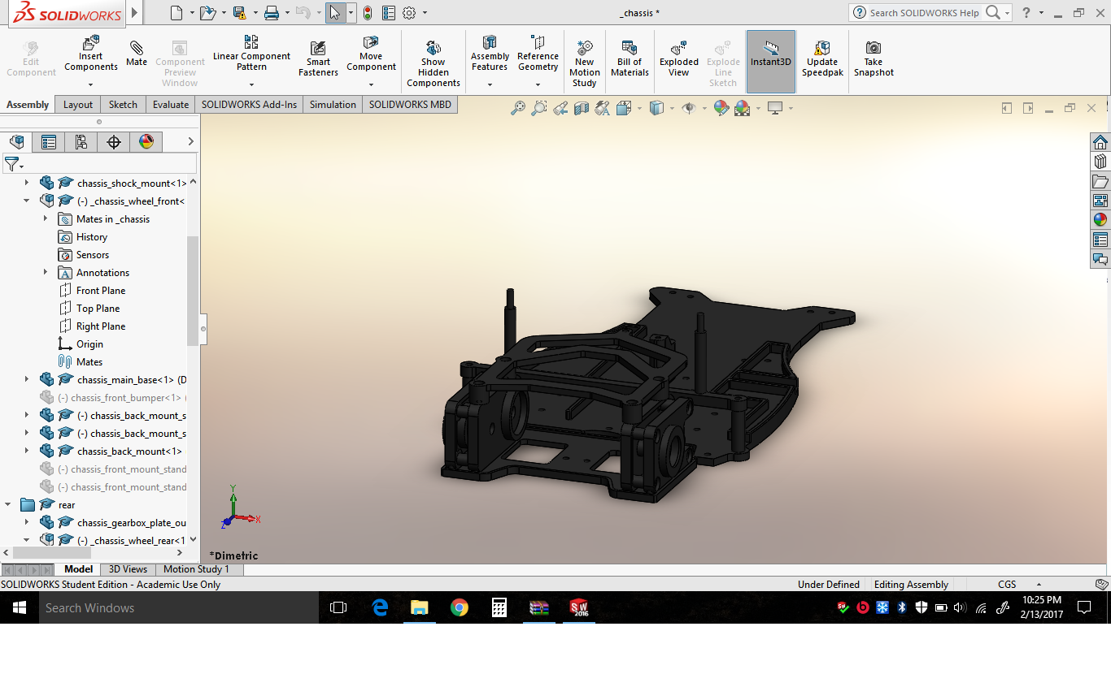Detailed Mechanical Drawings of Vehicle

Fig 1. Drawing of Car Base and framework

Yes we can change the battery pack without unscrewing anything. We are doing this so that we remove the battery pack in case of malfunction and complete discharge.

Switches are readily accessible on the side of the base plate. Yes we have left room for the expansion circuitry for future enhancements.

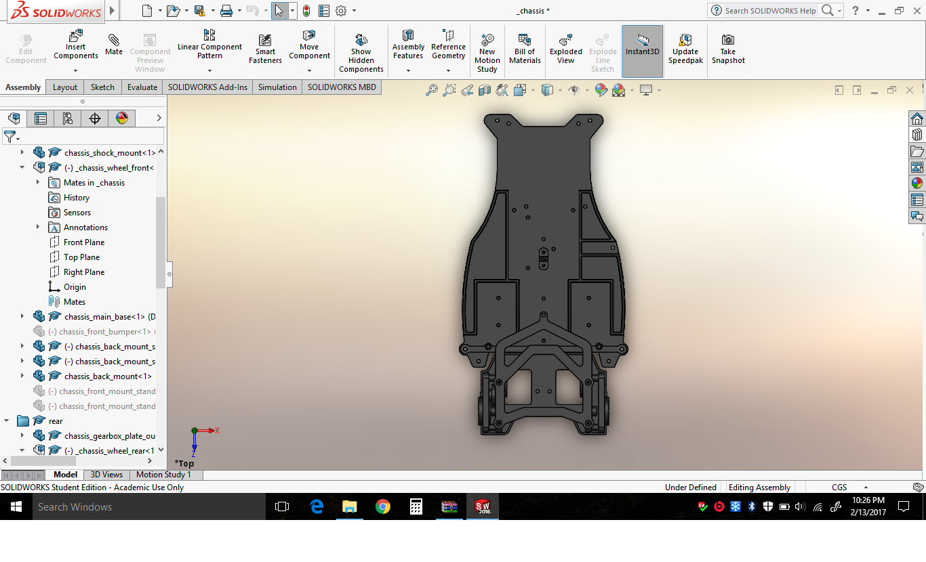Fig 2. Top View of Base Plate

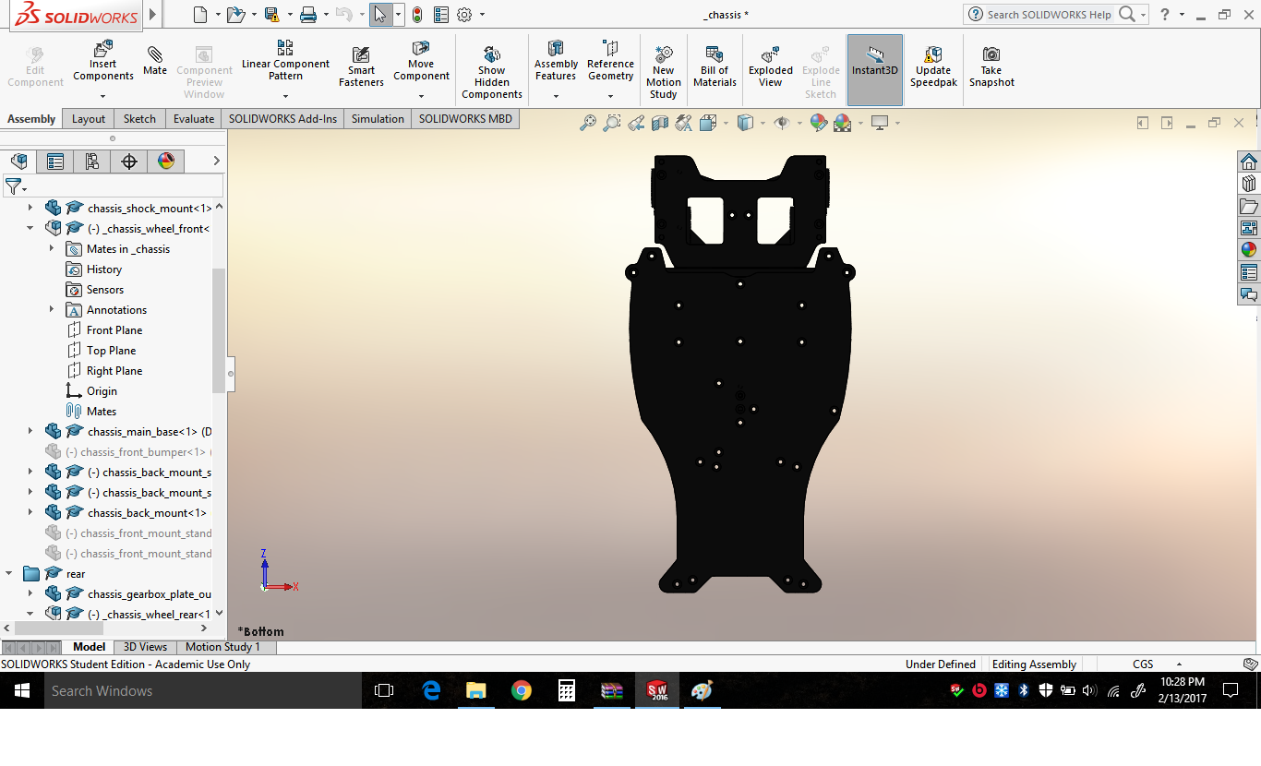

Fig 3. Bottom View of Base Plate

* 1. List of Special Materials
* Plastic brackets – 10 approx. for holding together of various components in the car
* Bunch of female and male connectors
* Plastic Base of the car (Chassis)
* 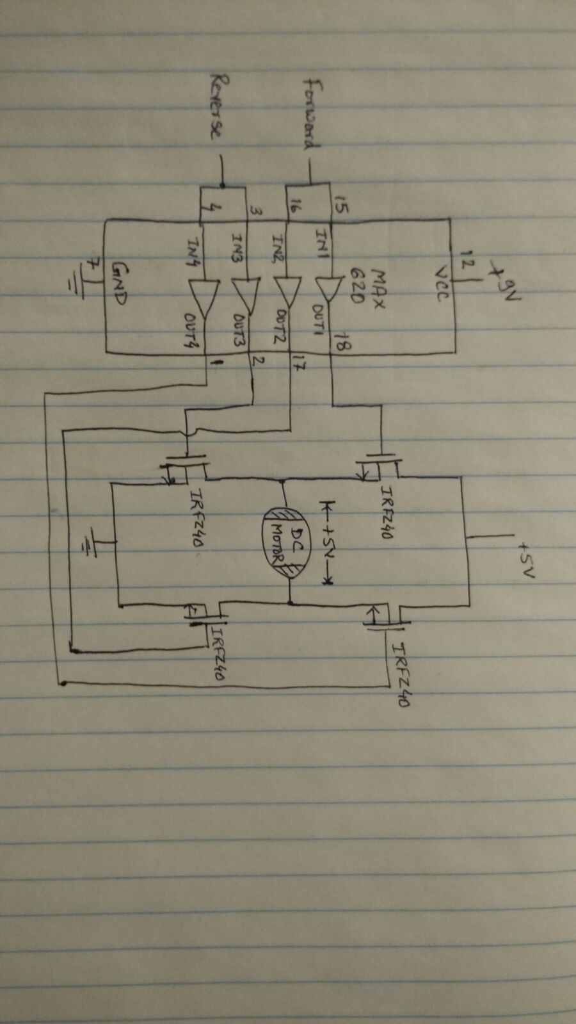Mounts for Camera
* Battery pack and zip ties to hold it in place
* Zip Ties for holding battery
* Jumper wires for interconnections

Yes, we will require to use the 3D printer for certain parts and enclosures.

3.4. Motor Drive Circuitry

Fig 4. Motor Driver H Bridge Circuitry

The Pin Connections will be decided later. Since we are going to use 2 motors for driving the rear wheels we need 2 MAX620 IC’s for controlling 2 motors. The H-Bridge will be used to control the wheel motion forward and backward. We may use the back emf to measure the speed. The Reverse control may be used for reverse braking.

1. **Software Design**

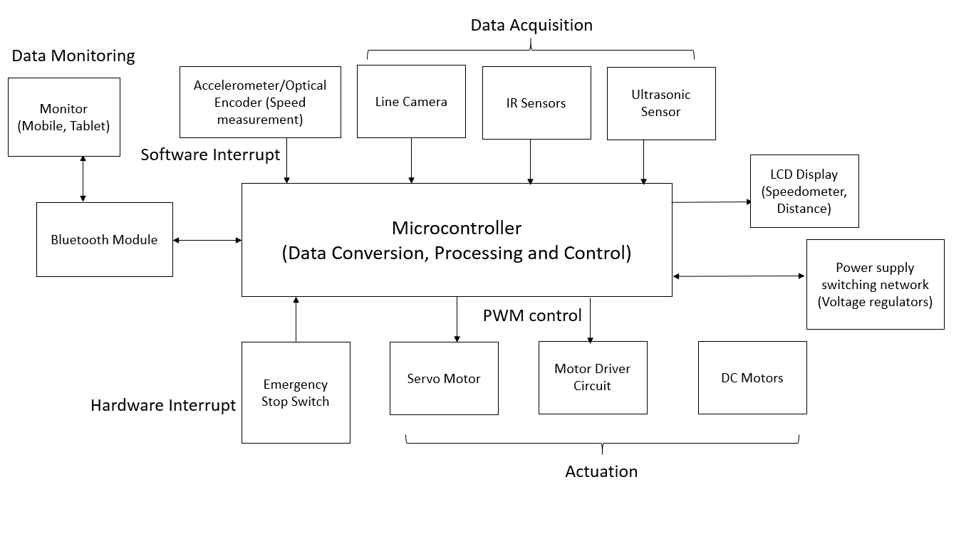

**Fig 5. Block Diagram of the software system**

* Our software design will focus primarily on expert navigation and precise steering.
* For high quality resolution, we will be using 8/16 bit Line camera sensor for proper navigation control